**7th Grade Supply List**

**2023-2024**

**Personal Supplies for all classes**

* backpack (larger size; can have wheels if desired)
* several packages of loose-leaf notebook paper
* 100 sheet bound composition notebook (**no spiral, please**)- **NOT** perforated – college ruled
* Pencils
* 2 blue or black pens
* Small pack of highlighters
* 1pk post-it or sticky notes
* 1 package 3x5 index cards
* Glue sticks (small pack)
* Ear buds (cheap pair is just fine.)
* Colored pencils (small pack)
* Handheld Pencil Sharpeners – not required, but helpful.
* 2-pocket folder
* Texas Instruments TI-30xs calculator (typically white with a grey cover)

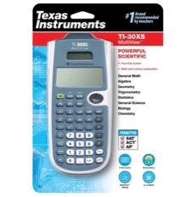

**Supplies to be turned in to Homeroom Teacher:** not required but very much appreciated.

* 3 boxes of tissues
* 1 roll of Paper Towels
* 1 box of Band Aids
* 1 pack of wipes and/or 1 canister of disinfecting wipes
* 1 bottle of Hand Sanitizer

**Please Note:**

Other supplies may be requested by individual teachers after school begins.